# Task 1 – Create EC2 Instance

Login to AWS Console.

Navigate to:

EC2 → Instances → Launch Instance
Configuration:

Name
web-server

AMI
Amazon Linux 2
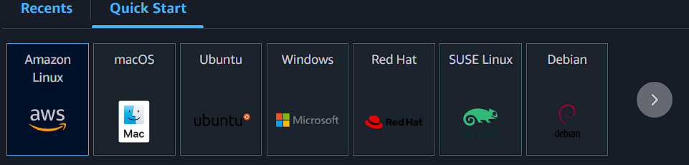
Instance Type
t2.micro
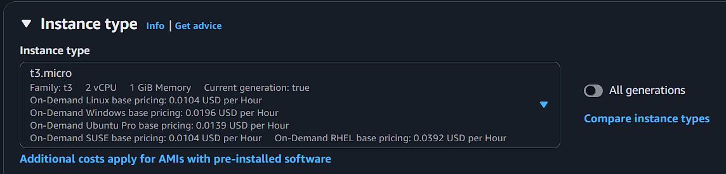
Key Pair
Select existing key pair
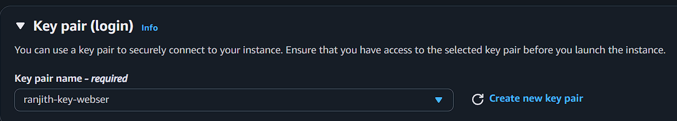
Security Group Rules
SSH – Port 22 – My IP
HTTP – Port 80 – Anywhere
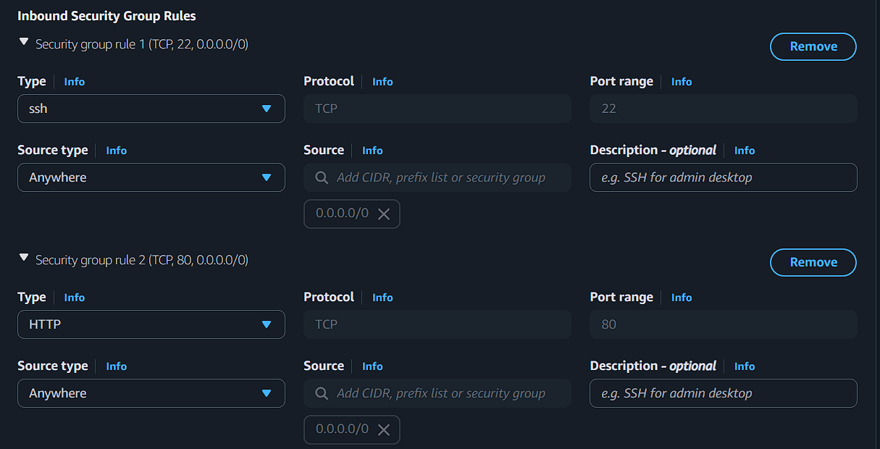
---
# Task 2 – Install Web Server using User Data

In **Advanced Details → User Data**, add the following script.

```bash
#!/bin/bash
yum update -y
yum install httpd -y
systemctl start httpd
systemctl enable httpd
echo "<h1>Welcome to AWS Auto Scaling Lab</h1>" > /var/www/html/index.html
```

Launch the instance.
After instance is running, verify the website using:
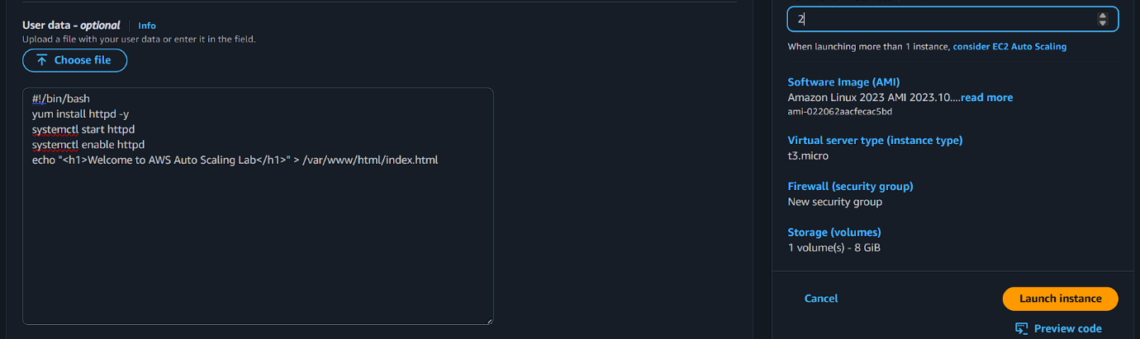
```
http://<EC2-Public-IP>
```
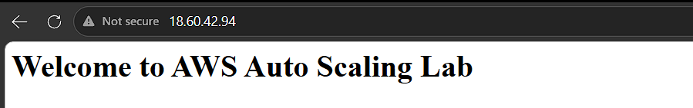
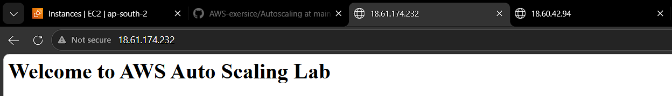
---

# Task 3 – Create Target Group

Navigate to:

EC2 → Target Groups → Create Target Group
Configuration
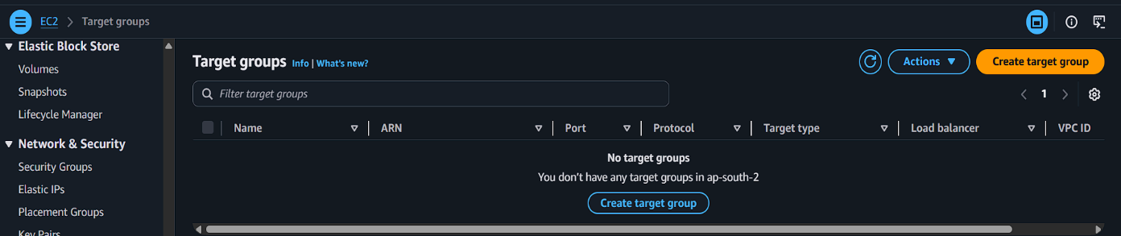
Target Type
Instances
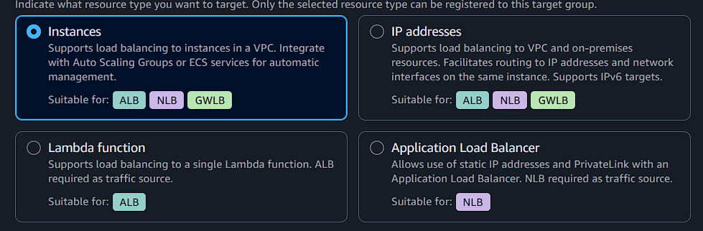
Protocol
HTTP
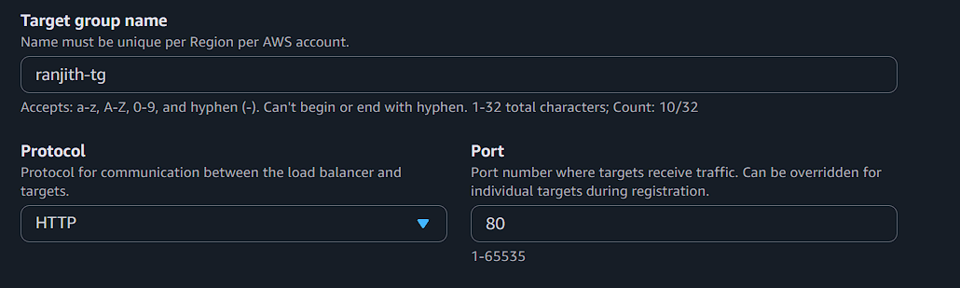
Port
80

VPC
Default VPC

Health Check Path

```
/
```

Click **Next**

Register the EC2 instance.
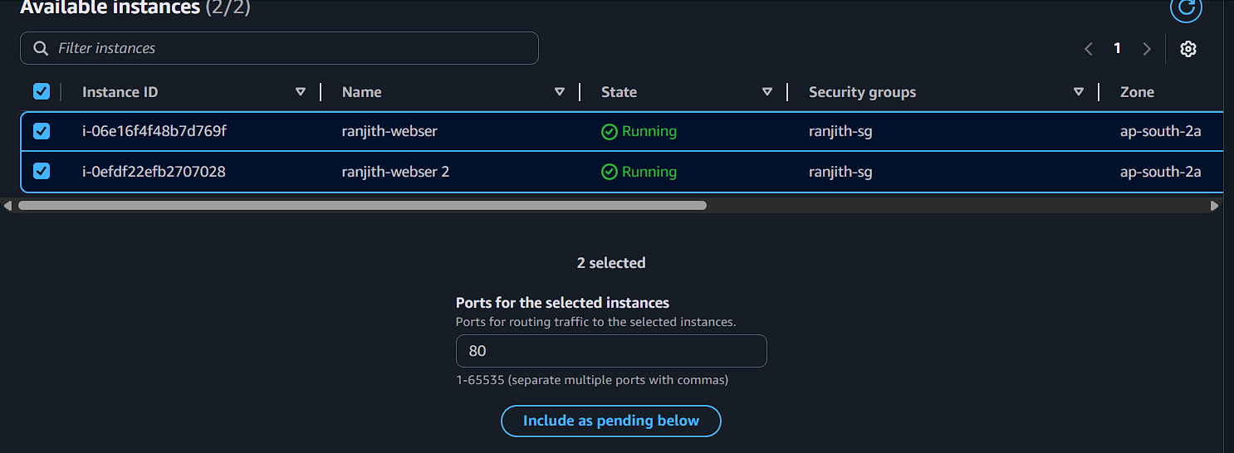
Click **Create Target Group**
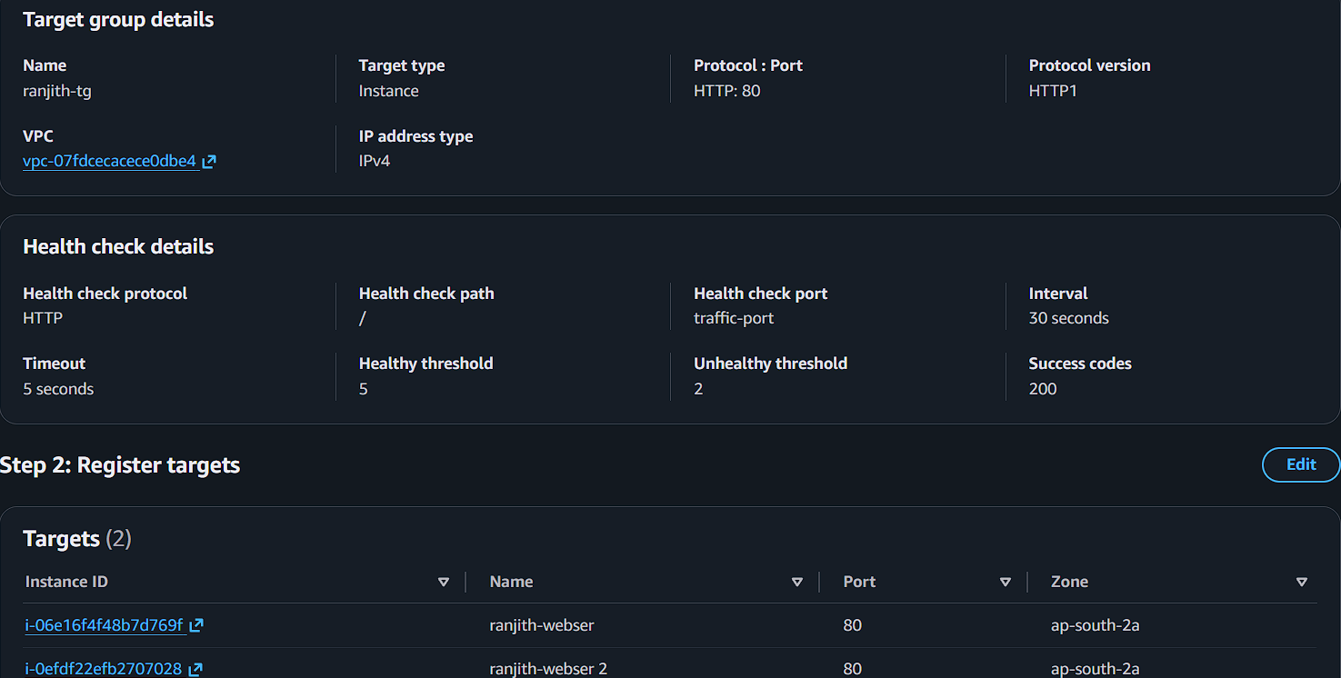

---

# Task 4 – Create Application Load Balancer

Navigate to:

EC2 → Load Balancers → Create Load Balancer
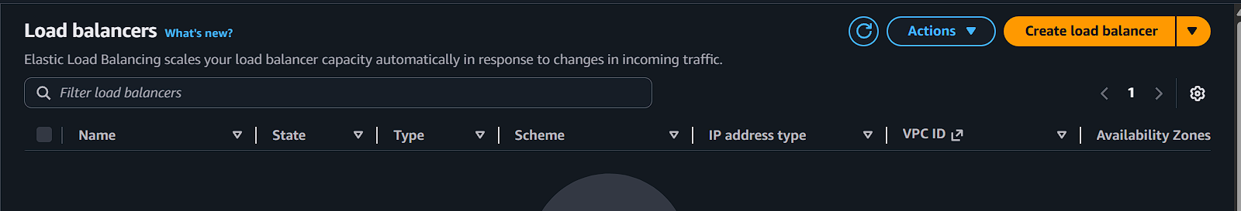
Choose:

Application Load Balancer
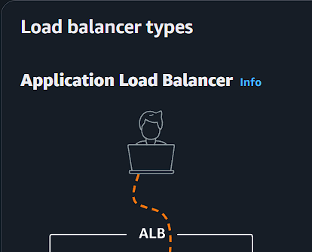
Configuration

Name
web-alb
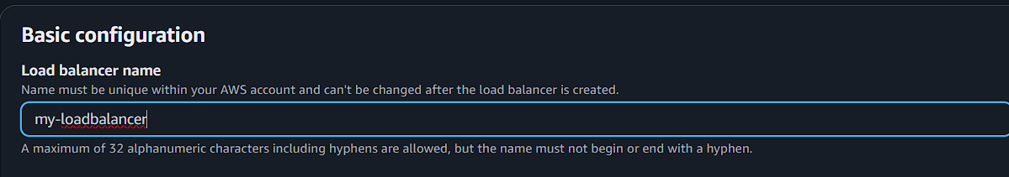
Scheme
Internet Facing
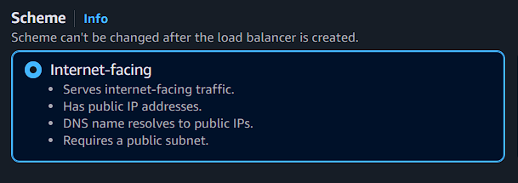
IP Address Type
IPv4
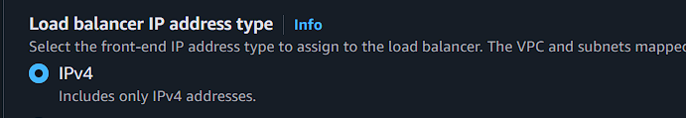
Listener
HTTP – Port 80

Select at least **two subnets**.
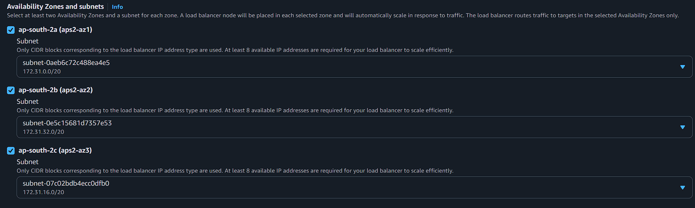
Security Group

Allow:

HTTP – Port 80
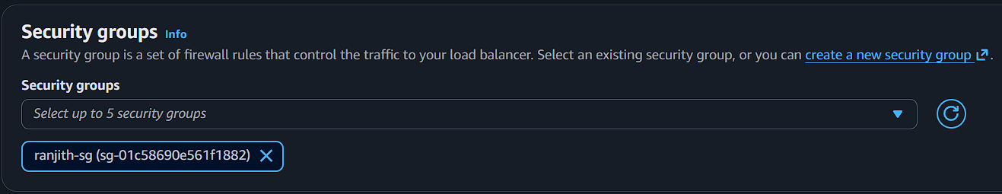
Routing
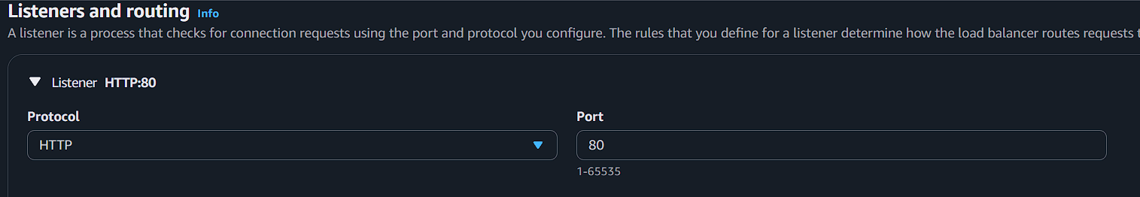
Select the **Target Group created earlier**

Create Load Balancer.

---

# Task 5 – Create Launch Template

Navigate to:

EC2 → Launch Templates → Create Launch Template
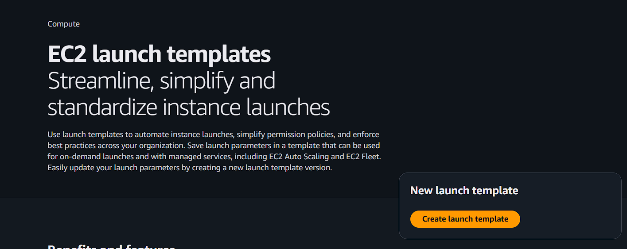
Configuration

Template Name

autoscaling-template

AMI
Amazon Linux 2
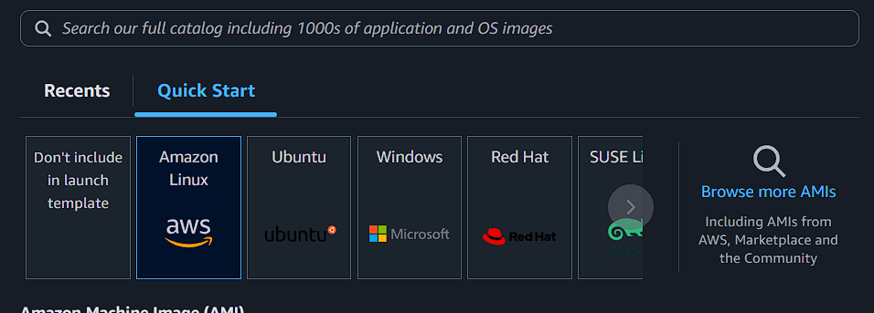
Instance Type
t2.micro
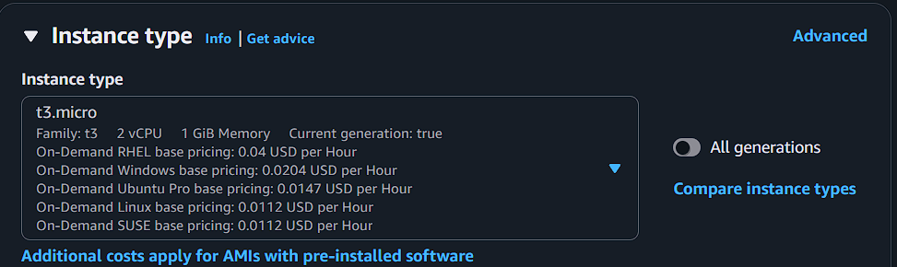
Key Pair
Select key pair
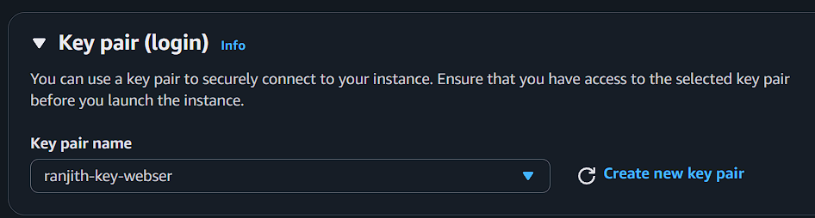
Security Group
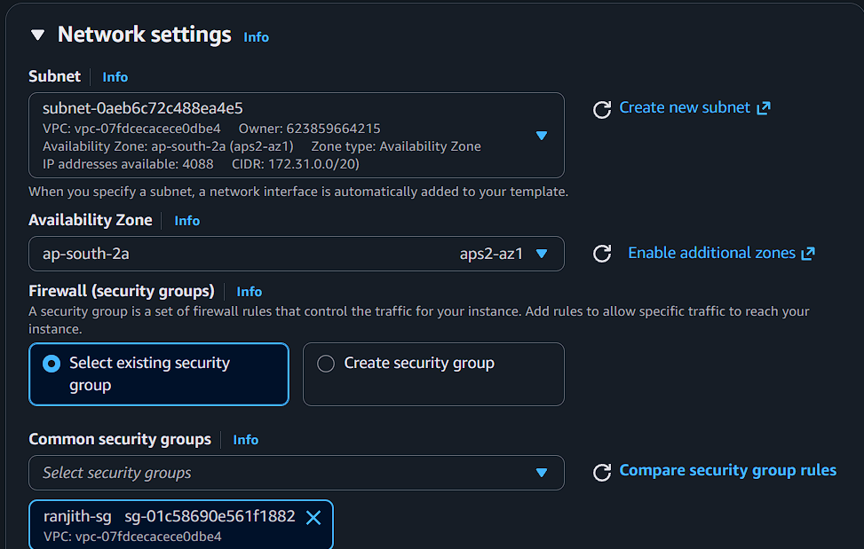
Allow:

SSH – 22
HTTP – 80

User Data Script

```bash
#!/bin/bash
yum update -y
yum install httpd -y
systemctl start httpd
systemctl enable httpd
echo "<h1>Instance created from Auto Scaling</h1>" > /var/www/html/index.html
```
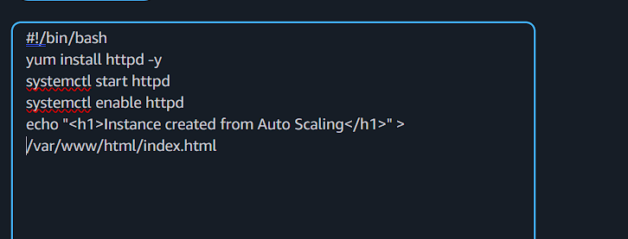
Create Launch Template.
---

# Task 6 – Create Auto Scaling Group

Navigate to:

EC2 → Auto Scaling Groups → Create Auto Scaling Group
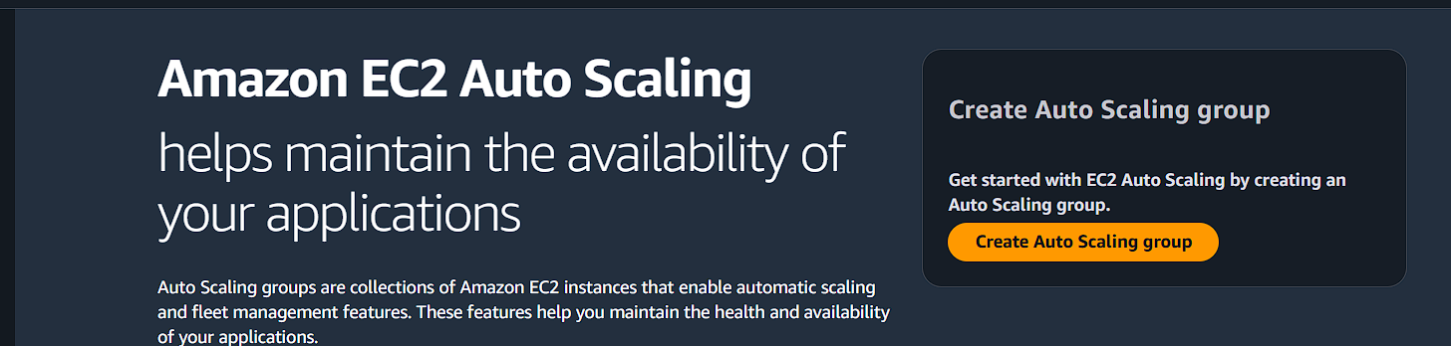
Configuration

Name
web-asg

Launch Template
autoscaling-template
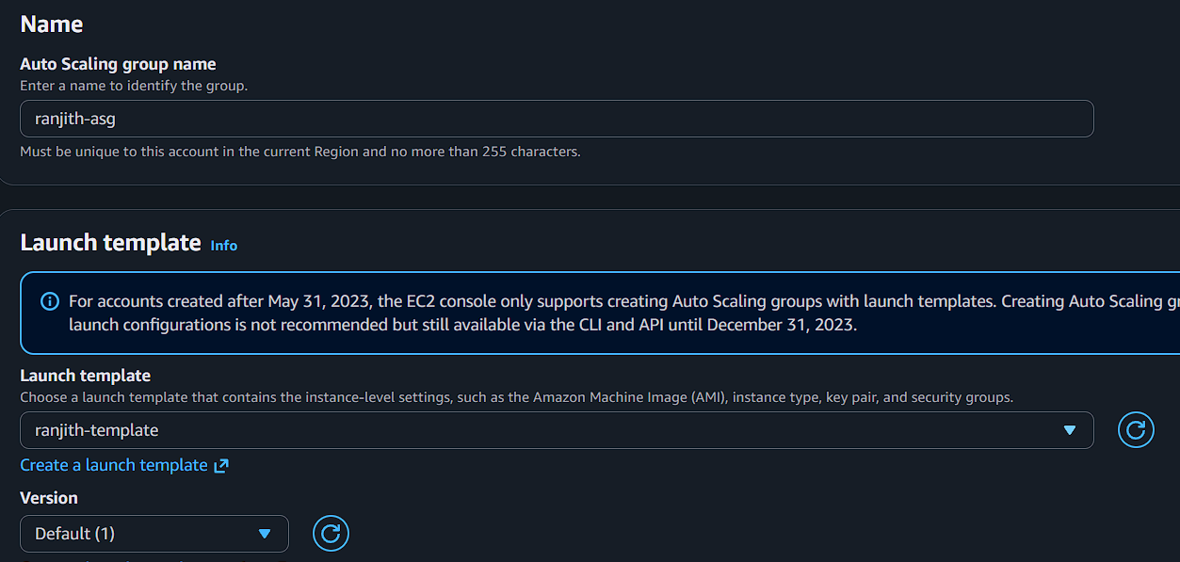
Network

Select VPC

Select **two subnets**
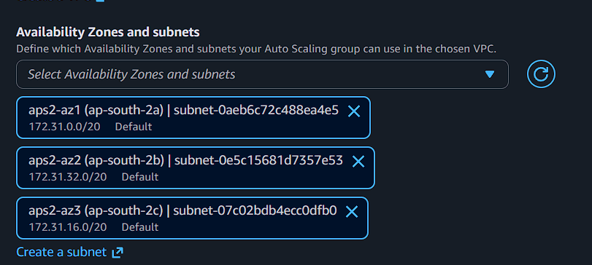
Click **Next**

---

# Task 7 – Attach Load Balancer

Select:

Attach to an existing load balancer
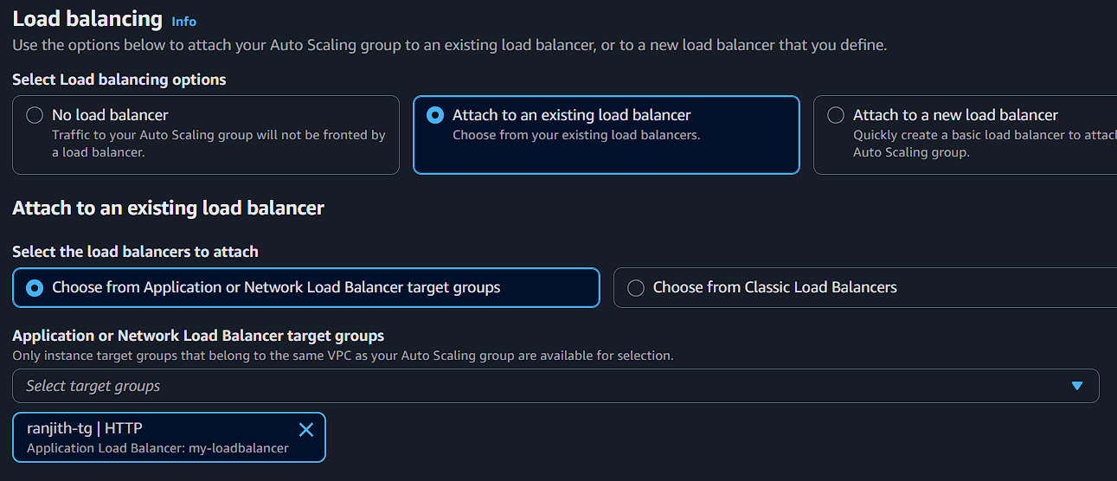
Choose:

Application Load Balancer

Select Target Group

```
web-target-group
```

Click **Next**

---

# Task 8 – Configure Group Size

Minimum Capacity

```
1
```
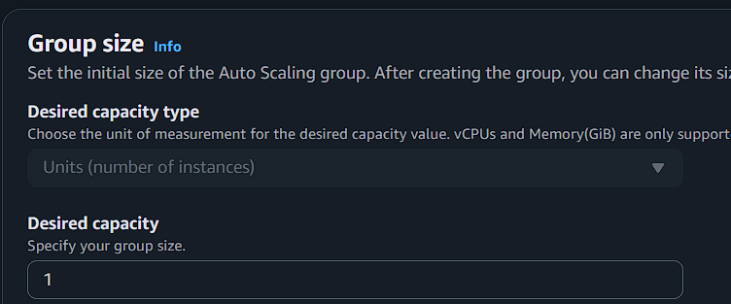
Desired Capacity

```
1
```

Maximum Capacity

```
3
```
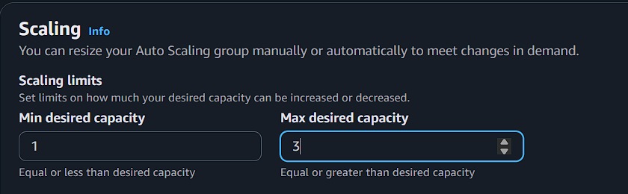
Click **Next**

---

# Task 9 – Configure Scaling Policy

Select:

Target Tracking Scaling Policy

Metric Type

```
Average CPU Utilization
```

Target Value

```
50%
```

Create the Auto Scaling Group.
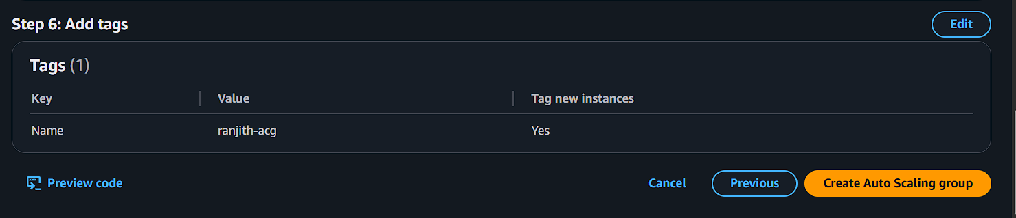
---

# Task 10 – Test Auto Scaling using CPU Load

Connect to the running EC2 instance using SSH.

Example

```
ssh ec2-user@<instance-ip>
```

Generate CPU load.

```bash
yes > /dev/null &
```

Check CPU usage.

```bash
top
```

When CPU usage exceeds **50%**, Auto Scaling will automatically launch a new EC2 instance.

Verify in:

EC2 → Auto Scaling Groups → Activity
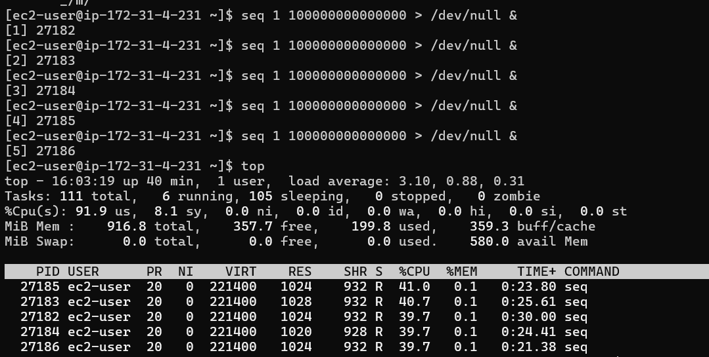

---

# Stop CPU Load

```bash
killall yes
```
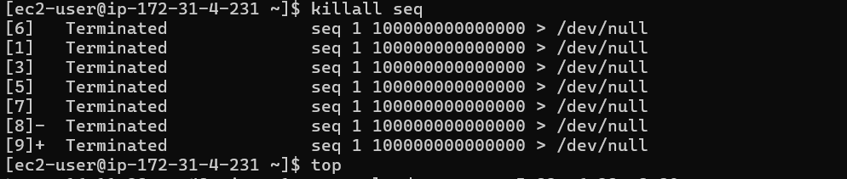
---

# Verify Scaling

Check:

EC2 → Instances

You should see a **new instance launched automatically**.
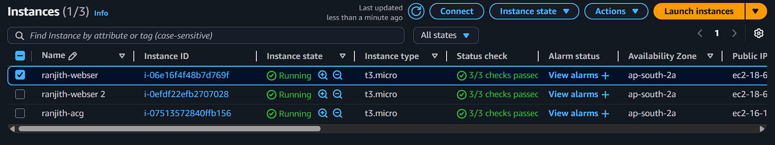
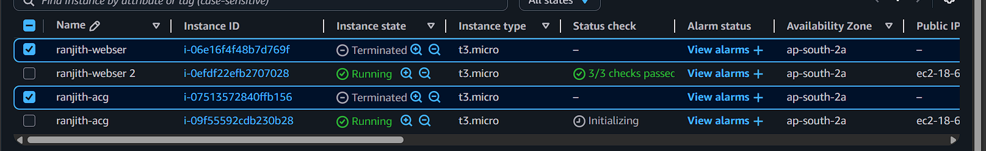
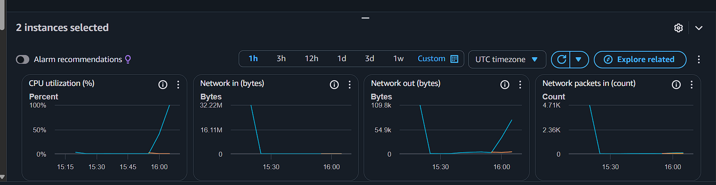
---
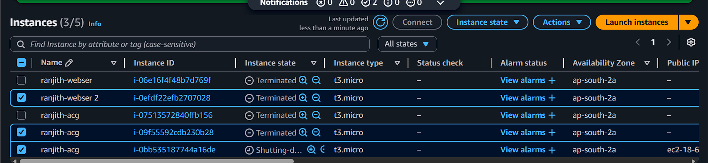
# Cleanup (Important)

To avoid AWS charges delete the following resources.

1. Auto Scaling Group
2. Load Balancer
3. Target Group
4. EC2 Instances
5. Launch Template

